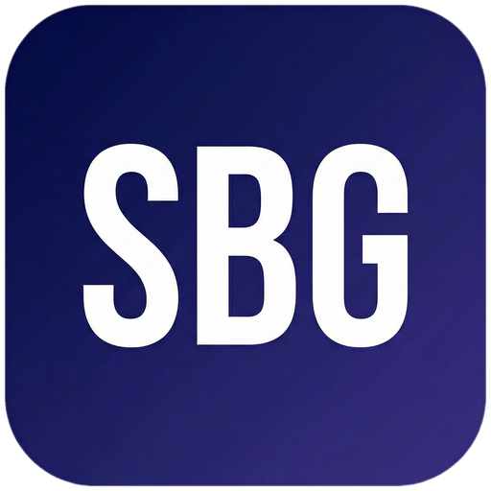 Small Business Guide  www.smallbusinessguide.co.uk | TERMS & CONDITIONS

WEBSITE TERMS AND CONDITIONS
Last Updated: [DATE]
Please read these Terms and Conditions carefully before using [Website URL] (the "Website") operated by [Company Name] ("we", "us", "our"). By accessing or using our Website, you agree to be bound by these Terms.
1. Introduction & Acceptance
These Terms and Conditions govern your use of our Website and form a legally binding agreement between you and [Company Name] (registered in England and Wales, Company No. [XXXXXXXX]).
If you do not agree with any part of these Terms, you must not use our Website.
2. Definitions
"Company" means [Company Name]; "Website" means [URL]; "User" means any person accessing the Website; "Services" means the services offered through the Website; "Content" means all text, images, videos, and other material on the Website.
3. Use of Website
You may use the Website only for lawful purposes. You must not: use the Website in any way that violates applicable local, national, or international law; transmit unsolicited commercial communications; attempt to gain unauthorised access to any part of the Website; scrape or harvest data without our written consent; infringe any intellectual property rights.
4. Intellectual Property
All content on this Website, including but not limited to text, graphics, logos, images, and software, is the property of [Company Name] or its content suppliers and is protected by UK and international copyright laws.
You are granted a limited, non-exclusive licence to access and use the Website for personal, non-commercial purposes only.
5. Privacy & Data Protection
Your use of the Website is also governed by our Privacy Policy, which is incorporated into these Terms by reference. We process personal data in accordance with the UK General Data Protection Regulation (UK GDPR) and the Data Protection Act 2018.
6. Disclaimers
The Website is provided on an "as is" and "as available" basis. We make no warranties, express or implied, regarding the accuracy, completeness, or fitness for a particular purpose of the content on this Website.
We do not guarantee that the Website will be uninterrupted, error-free, or free of viruses.
7. Limitation of Liability
To the fullest extent permitted by law, [Company Name] shall not be liable for any indirect, incidental, special, consequential, or punitive damages arising from your use of the Website.
Our total liability to you shall not exceed £100 or the total fees paid by you to us in the 12 months preceding the claim, whichever is greater.
8. Third Party Links
Our Website may contain links to third-party websites. These links are provided for your convenience only. We have no control over the content of those sites and accept no responsibility for them or for any loss or damage that may arise from your use of them.
9. Governing Law
These Terms shall be governed by and construed in accordance with the laws of England and Wales. Any disputes shall be subject to the exclusive jurisdiction of the courts of England and Wales.
10. Changes to Terms
We reserve the right to modify these Terms at any time. We will notify you of significant changes by posting a notice on the Website. Your continued use of the Website after such changes constitutes your acceptance of the new Terms.
11. Contact Details
If you have any questions about these Terms, please contact us at:
[Company Name], [Address], [Email], [Phone]

Template provided free by Small Business Guide · www.smallbusinessguide.co.uk · All SBG branding may be removed and replaced with your own business brand. · Not legal or financial advice.

