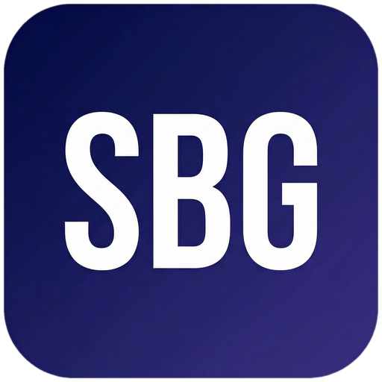 Small Business Guide  www.smallbusinessguide.co.uk | RISK ASSESSMENT

RISK ASSESSMENT
Compliant with the Health & Safety at Work Act 1974 and the Management of Health & Safety at Work Regulations 1999. Guidance from the Health and Safety Executive (HSE).
ASSESSMENT DETAILS
Business Name: | [Business Name]
Site / Activity Being Assessed: | [Location or Activity]
Assessment Date: | [DD/MM/YYYY]
Review Date: | [DD/MM/YYYY — review at least annually or after any incident]
Assessor Name & Job Title: | [Name], [Job Title]
Approved By: | [Manager Name], [Title]

RISK RATING MATRIX
Risk Rating = Likelihood (1–5) × Severity (1–5)
L \ S | Severity 1 | Severity 2 | Severity 3 | Severity 4 | Severity 5
Likelihood 1 | 1  Low | 2  Low | 3  Low | 4  Low | 5  Med
Likelihood 2 | 2  Low | 4  Low | 6  Med | 8  Med | 10  Med
Likelihood 3 | 3  Low | 6  Med | 9  Med | 12  Med | 15  High
Likelihood 4 | 4  Low | 8  Med | 12  Med | 16  High | 20  High
Likelihood 5 | 5  Med | 10  Med | 15  High | 20  High | 25  High
RISK REGISTER
No. | Hazard | Who Affected | Existing Controls | L | S | Rating | Additional Actions | Owner | Target Date | Completed
1 | Slips, Trips & Falls | All staff, visitors | Regular housekeeping; non-slip flooring; adequate lighting; clear walkways; wet floor signs used | 2 | 3 | 6 | Review lighting levels in [area] | [Name] | [Date]
2 | Manual Handling | Warehouse/delivery staff | Manual handling training provided; team lifts for heavy items; trolleys available; weight limits posted | 2 | 4 | 8 | Refresh manual handling training | [Name] | [Date]
3 | Fire | All persons on premises | Fire risk assessment completed; fire alarms tested weekly; extinguishers serviced annually; evacuation procedure posted; fire drills twice yearly | 2 | 5 | 10 | Review fire evacuation plan | [Name] | [Date]
4 | Electrical Hazards | All staff | PAT testing of portable appliances annually; fixed wiring inspection every 5 years; faulty equipment reported and removed from use | 2 | 4 | 8 | Schedule next PAT test | [Name] | [Date]
5 | Display Screen Equipment (DSE) | Office-based staff | DSE assessments completed for all regular users; adjustable chairs and monitors provided; regular breaks encouraged; eye test vouchers offered | 3 | 2 | 6 | Complete DSE assessment for new starters | [Name] | [Date]
6 | Lone Working | Staff working alone | Lone working policy in place; check-in procedure; emergency contact details held; mobile phone provided | 3 | 3 | 9 | Review lone working policy | [Name] | [Date]
7 | Work-Related Stress & Mental Health | All staff | Regular 1-2-1s with line managers; Employee Assistance Programme (EAP) available; workload monitoring; mental health first aider trained | 3 | 3 | 9 | Promote EAP to all staff | [Name] | [Date]
8 | Infection Control | All staff and visitors | Handwashing facilities available; hand sanitiser provided; surfaces cleaned regularly; staff encouraged to stay home when unwell | 2 | 3 | 6 | Review cleaning schedule | [Name] | [Date]
9 | Chemical/COSHH Hazards | Cleaning/maintenance staff | COSHH assessments completed; SDS sheets available; PPE provided (gloves, eye protection); chemicals stored securely; staff trained | 2 | 4 | 8 | Review COSHH assessments | [Name] | [Date]
10 | Violence & Aggression | Customer-facing staff | Conflict resolution training provided; lone working avoided in high-risk situations; incident reporting procedure in place; CCTV installed | 2 | 4 | 8 | Refresh conflict resolution training | [Name] | [Date]
11 | Working at Height | Maintenance/facilities staff | Working at height avoided where possible; ladders inspected before use; scaffolding used for prolonged work; two-person rule for ladders | 2 | 5 | 10 | Review ladder inspection records | [Name] | [Date]
12 | Vehicle/Traffic Movement | Drivers and pedestrians on site | Pedestrian and vehicle routes separated; speed limits enforced; reversing cameras on vehicles; banksman used for reversing in busy areas | 2 | 4 | 8 | Review site traffic management plan | [Name] | [Date]

Template provided free by Small Business Guide · www.smallbusinessguide.co.uk · All SBG branding may be removed and replaced with your own business brand. · Not legal or financial advice.

