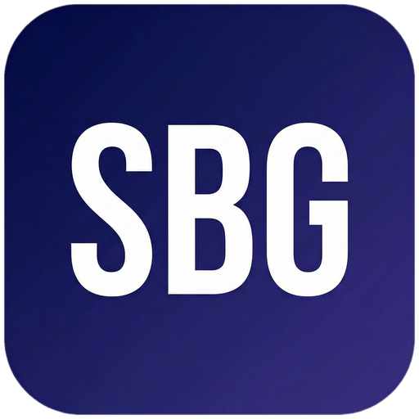 Small Business Guide  www.smallbusinessguide.co.uk | PRIVACY POLICY

PRIVACY POLICY
Last Updated: [DATE]
[Company Name] is committed to protecting your privacy. This Privacy Policy explains how we collect, use, and protect your personal data in accordance with the UK General Data Protection Regulation (UK GDPR) and the Data Protection Act 2018.
1. Who We Are
[Company Name] is the data controller for personal data collected through this website.
Registered address: [Address]. Company Registration No.: [XXXXXXXX].
ICO Registration No.: [ZxxxxxxX]. Data Protection Contact: [email@company.com]
2. What Personal Data We Collect
We may collect the following categories of personal data:
• Identity data: name, username, title
• Contact data: email address, telephone number, postal address
• Financial data: payment card details (processed securely via [payment provider])
• Technical data: IP address, browser type, device information, cookies
• Usage data: information about how you use our website and services
• Marketing preferences: your preferences for receiving marketing from us
3. How We Collect Your Data
We collect data through: (a) direct interactions (forms, email, phone); (b) automated technologies (cookies, analytics); (c) third parties (social media, analytics providers, advertising networks).
4. Legal Basis for Processing
We process your personal data on the following legal bases:
• Contract: to fulfil our contractual obligations to you
• Legitimate interests: to improve our services, prevent fraud, and for direct marketing to existing customers
• Consent: for email marketing to new contacts (you may withdraw consent at any time)
• Legal obligation: to comply with our legal and regulatory requirements
5. How We Use Your Data
We use your personal data to: provide and improve our services; process transactions; send service communications; send marketing communications (where you have consented or we have a legitimate interest); comply with legal obligations; prevent fraud and abuse.
6. Who We Share Your Data With
We may share your data with: service providers acting as data processors (IT, payment processing, email delivery); professional advisors (lawyers, accountants); regulatory authorities where required by law.
We do not sell your personal data to third parties.
7. Your Rights
Under UK GDPR, you have the right to: access your personal data; rectify inaccurate data; request erasure ("right to be forgotten"); restrict processing; data portability; object to processing; withdraw consent at any time.
To exercise any of these rights, contact us at [email]. You also have the right to lodge a complaint with the Information Commissioner's Office (ICO) at ico.org.uk or 0303 123 1113.
8. Data Retention
We retain personal data only for as long as necessary for the purposes for which it was collected. Customer records are retained for [6] years after the end of the business relationship in accordance with HMRC requirements. Marketing data is retained until you unsubscribe.
9. Cookies
We use essential cookies (required for the website to function), analytics cookies (to understand how visitors use our site, e.g. Google Analytics), and marketing cookies (to deliver relevant advertising). You can control cookies through your browser settings or our cookie consent tool.
10. Contact Us
For any privacy-related queries, contact: [Data Protection Contact], [Company Name], [Address], [Email]. To complain to the ICO: ico.org.uk

Template provided free by Small Business Guide · www.smallbusinessguide.co.uk · All SBG branding may be removed and replaced with your own business brand. · Not legal or financial advice.

