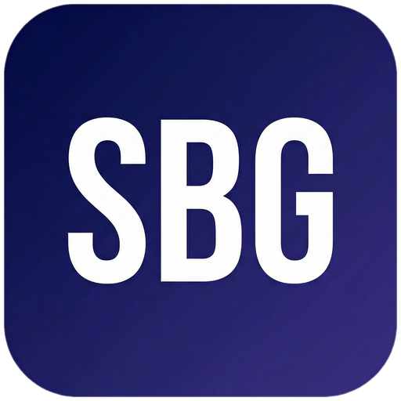 Small Business Guide  www.smallbusinessguide.co.uk | EMPLOYEE HANDBOOK

EMPLOYEE HANDBOOK
COVER
[Company Name]
Version [1.0] | Effective Date: [DATE]
This handbook contains important information about your employment. Please read it carefully and keep it for reference.
1. WELCOME & INTRODUCTION
Welcome to [Company Name]! We are delighted to have you as part of our team.
[Write a personal welcome message from the MD/CEO here — introduce the company, its history, and what makes it a great place to work.]
Our Mission: [One sentence]
Our Vision: [Where we are going]
Our Values: [Value 1] — [brief description]; [Value 2] — [brief description]; [Value 3] — [brief description]
2. EMPLOYMENT POLICIES
Equal Opportunities: [Company Name] is an equal opportunities employer. We are committed to creating an inclusive environment for all employees, regardless of age, disability, gender, race, religion or belief, sex, or sexual orientation, in accordance with the Equality Act 2010.
Anti-Harassment & Bullying: We have zero tolerance for harassment, bullying, or discrimination of any kind. Any employee found to have engaged in such behaviour will be subject to disciplinary action, up to and including dismissal.
Anti-Bribery: We are committed to conducting business ethically and in compliance with the Bribery Act 2010. Employees must not offer, give, receive, or request any bribe or improper payment.
Whistleblowing: Employees who have genuine concerns about wrongdoing within the Company are encouraged to report them. Whistleblowers are protected under the Public Interest Disclosure Act 1998.
3. WORKING HOURS & FLEXIBLE WORKING
Standard working hours are [X] hours per week, [Monday to Friday], [9am to 5pm].
Flexible Working: Employees with [26] weeks' continuous service have the right to request flexible working arrangements under the Employment Relations (Flexible Working) Act 2023. Requests must be made in writing.
Overtime: [Describe overtime policy — paid/unpaid, rate, authorisation required]
Rest Breaks: You are entitled to a [20-minute] rest break when working more than 6 hours, in accordance with the Working Time Regulations 1998.
4. PAY & BENEFITS
Pay Dates: Salaries are paid [monthly] on the [last working day] of each month by BACS transfer.
Expenses: Legitimate business expenses will be reimbursed on submission of a completed expense form with receipts. Expenses must be pre-approved by your line manager.
Pension: You will be automatically enrolled in our workplace pension scheme in accordance with auto-enrolment legislation. Employer contribution: [X]%. Employee contribution: [X]%.
Benefits: [List any additional benefits — e.g. private medical insurance, life assurance, cycle to work scheme, employee discounts, training budget]
5. HOLIDAY & LEAVE
Annual Leave: You are entitled to [28] days' paid holiday per year including bank holidays (statutory minimum). The holiday year runs [1 April to 31 March].
Booking Holiday: Holiday must be requested through [system/manager] with at least [X weeks'] notice. Approval is subject to business needs.
Sick Leave: If you are unable to attend work, notify your line manager by [TIME] on the first day. Self-certification is required for absences up to 7 days. A fit note from your GP is required for longer absences. SSP is payable in accordance with current legislation.
Parental Leave: Employees are entitled to statutory maternity, paternity, adoption, and shared parental leave in accordance with current legislation. Please speak to HR for details.
6. PERFORMANCE & DEVELOPMENT
Probationary Period: Your employment is subject to a [3/6]-month probationary period. Your performance will be reviewed at [1 month] and [3 months].
Annual Appraisals: All employees receive an annual performance appraisal. This is an opportunity to review your achievements, set objectives for the coming year, and discuss your development.
Training & Development: We are committed to your professional development. Training needs will be identified through your appraisal. A training budget of £[X] per employee per year is available.
7. DISCIPLINARY PROCEDURE
We aim to resolve issues informally where possible. Where formal action is required, the following procedure applies:
Stage 1 — Verbal Warning: For minor misconduct or performance issues.
Stage 2 — First Written Warning: If the issue continues or for more serious matters.
Stage 3 — Final Written Warning: For repeated or serious misconduct.
Stage 4 — Dismissal: For gross misconduct or continued failure to improve.
Gross Misconduct: Examples include theft, fraud, violence, serious harassment, and serious breach of confidentiality. Gross misconduct may result in summary dismissal.
You have the right to be accompanied at any formal disciplinary hearing by a colleague or trade union representative under the Employment Relations Act 1999.
This procedure complies with the ACAS Code of Practice on Disciplinary and Grievance Procedures.
8. GRIEVANCE PROCEDURE
If you have a grievance relating to your employment, you should first try to resolve it informally with your line manager.
If informal resolution is not possible, you may raise a formal grievance in writing to [HR/Director].
A grievance hearing will be arranged within [10] working days. You have the right to be accompanied.
You will receive a written response within [5] working days of the hearing. You have the right to appeal.
9. HEALTH & SAFETY
We are committed to providing a safe and healthy working environment in accordance with the Health & Safety at Work Act 1974.
Employees must: take reasonable care of their own health and safety; cooperate with the Company's health and safety measures; report any hazards or accidents immediately.
Accidents must be reported to [Name/Role] and recorded in the accident book. RIDDOR reportable accidents must be reported to the HSE.
First aiders: [Name(s)]. First aid kit location: [Location].
10. DATA PROTECTION & CONFIDENTIALITY
We process employee personal data in accordance with the UK GDPR and the Data Protection Act 2018. You will receive a separate Employee Privacy Notice.
Employees must keep confidential all information relating to the Company, its clients, and its business during and after employment.
11. IT & SOCIAL MEDIA POLICY
Company IT systems are provided for business use. Limited personal use is permitted provided it does not interfere with your work.
You must not: access inappropriate websites; download unauthorised software; share login credentials; use company systems for personal commercial activities.
Social Media: You must not post content that could damage the Company's reputation, disclose confidential information, or bring the Company into disrepute.
12. LEAVING THE COMPANY
Notice: You are required to give [X weeks/months] notice of resignation in writing. The Company will give you the notice specified in your contract.
Exit Interview: We conduct exit interviews with all departing employees. Your feedback helps us improve.
Return of Property: All Company property (laptop, phone, keys, documents) must be returned on your last day.
References: We will provide factual references confirming your job title and dates of employment.

Template provided free by Small Business Guide · www.smallbusinessguide.co.uk · All SBG branding may be removed and replaced with your own business brand. · Not legal or financial advice.

