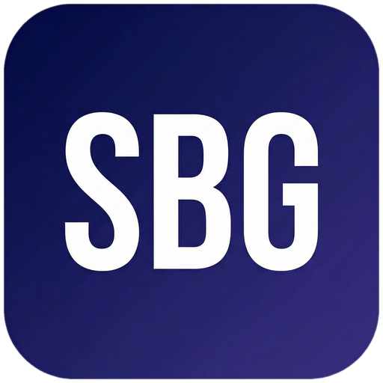 Small Business Guide  www.smallbusinessguide.co.uk | BUSINESS PROPOSAL

BUSINESS PROPOSAL
COVER PAGE
Prepared for: [Client Name / Company Name]
Prepared by: [Your Name] | [Your Company Name]
Date: [DATE] | Reference: [REF-001]
[Your Company Address] | [Email] | [Phone] | [Website]
1. EXECUTIVE SUMMARY
[Write this section last. Summarise the entire proposal in 3-5 sentences.]
We propose to [brief description of solution] for [Client Name], delivering [key benefit 1] and [key benefit 2].
Investment: £[TOTAL] [plus VAT] | Timeline: [X weeks/months] | Start Date: [DATE]
2. UNDERSTANDING YOUR NEEDS
Based on our conversations with [Client Name], we understand that you are facing the following challenges:
• [Challenge 1 — describe in the client's language, showing you understand their situation]
• [Challenge 2]
• [Challenge 3]
Your key objectives are: [Objective 1]; [Objective 2]; [Objective 3].
[Demonstrating that you truly understand the client's situation builds trust and differentiates you from competitors who send generic proposals.]
3. OUR PROPOSED SOLUTION
We propose the following approach to address your needs:
Phase 1 — [Phase Name]: [Description of what will be done, how, and why]
Phase 2 — [Phase Name]: [Description]
Phase 3 — [Phase Name]: [Description]
Key Deliverables:
Deliverable | Description | Timeline | Acceptance Criteria
[Deliverable 1] | [Description] | [Week X] | [How success is measured]
[Deliverable 2] | [Description] | [Week X] | [How success is measured]
[Deliverable 3] | [Description] | [Week X] | [How success is measured]
[Final Deliverable] | [Description] | [Week X] | [How success is measured]

4. WHY CHOOSE US
[USP 1 — e.g. Proven Track Record]: [Description of your experience and results]
[USP 2 — e.g. Dedicated Team]: [Description]
[USP 3 — e.g. Transparent Pricing]: [Description]
Case Study 1: [Client Name] — Challenge: [Brief description]. Solution: [What we did]. Result: [Measurable outcome].
Case Study 2: [Client Name] — Challenge: [Brief description]. Solution: [What we did]. Result: [Measurable outcome].
5. PROJECT TIMELINE
Phase | Activities | Wk 1 | Wk 2 | Wk 3 | Wk 4 | Wk 5 | Wk 6 | Wk 7 | Wk 8
Discovery | Briefing, research, planning | ✓ | ✓
Strategy | Strategy development, approval |  |  | ✓ | ✓
Execution | [Main deliverable work] |  |  |  |  | ✓ | ✓ | ✓
Review | QA, revisions, client review |  |  |  |  |  |  | ✓ | ✓
Delivery | Final handover, documentation |  |  |  |  |  |  |  | ✓

6. INVESTMENT
Item | Description | Qty | Unit Price (£) | Total (£)
[Item 1] | [Description] | [X] | £[X] | £[X]
[Item 2] | [Description] | [X] | £[X] | £[X]
[Item 3] | [Description] | [X] | £[X] | £[X]
[Item 4] | [Description] | [X] | £[X] | £[X]
Subtotal |  |  |  | £[X]
VAT (20%) |  |  |  | £[X]
TOTAL |  |  |  | £[X]

Payment Terms: [50% deposit on commencement, 50% on completion / Monthly instalments of £X / Other].
This proposal is valid for [30] days from the date of issue.
7. NEXT STEPS
To proceed, we suggest the following next steps:
1. Review this proposal and note any questions or amendments required.
2. Schedule a call to discuss — contact [Name] at [email] or [phone].
3. Sign and return the enclosed Client Service Agreement.
4. Pay the deposit invoice to secure your start date.
5. Project kickoff call on [proposed date].
We are excited about the opportunity to work with [Client Name] and are confident we can deliver outstanding results.
ACCEPTANCE
By signing below, [Client Name] agrees to proceed with this proposal on the terms set out above.
Client Signature: ___________________________ Print Name: ___________________________ Date: _______________
For [Your Company]: ___________________________ Print Name: ___________________________ Date: _______________

Partner Offer Need flexible funding to cover your startup or growth costs?
Capital on Tap offers a business credit card with up to £250,000 credit limit. Use code SETTINGUP when you apply and earn 1% cashback on all spending.
Apply at: cashback.capitalontap.com/referral/?promo=SETTINGUP&referrer=SETTINGUP

Template provided free by Small Business Guide · www.smallbusinessguide.co.uk · All SBG branding may be removed and replaced with your own business brand. · Not legal or financial advice.

