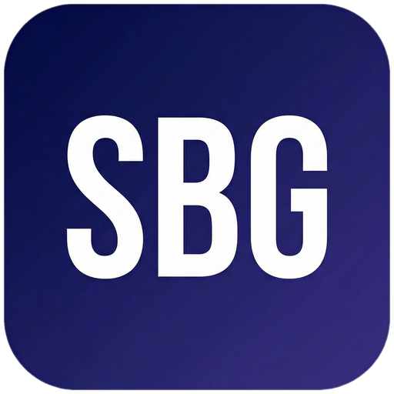 Small Business Guide  www.smallbusinessguide.co.uk | BUSINESS PLAN

BUSINESS PLAN
COVER PAGE
[Company Name]
Prepared by: [Name] | Date: [DATE] | Version: [1.0]
CONFIDENTIAL — This document contains confidential information. Do not distribute without permission.
1. EXECUTIVE SUMMARY
[Write this section last — it summarises the entire plan in 1-2 pages]
Business Concept: [2-3 sentences describing what your business does, who it serves, and how it makes money]
The Opportunity: [Describe the problem you solve or the gap in the market]
Competitive Advantage: [What makes you different from competitors?]
Metric | Year 1 | Year 2 | Year 3
Projected Revenue | £[X] | £[X] | £[X]
Projected Net Profit | £[X] | £[X] | £[X]
Headcount | [X] | [X] | [X]

Funding Required: £[X] for [purpose]. Expected break-even: [Month/Year].
2. BUSINESS DESCRIPTION
Company Name: [Legal name] | Trading As: [Trading name if different]
Legal Structure: [Sole Trader / Limited Company / Partnership / LLP]
Registered Address: [Address] | Companies House No.: [XXXXXXXX] (if applicable)
Mission Statement: [One sentence describing your purpose — why you exist]
Vision: [Where you want to be in 3-5 years]
Core Values: [Value 1], [Value 2], [Value 3], [Value 4]
Products/Services Overview: [Brief description of what you sell]
3. PRODUCTS & SERVICES
Product/Service 1: [Name] — [Description]. Price: £[X]. Target customer: [segment].
Product/Service 2: [Name] — [Description]. Price: £[X]. Target customer: [segment].
Key USPs (Unique Selling Points): [USP 1], [USP 2], [USP 3]
Product/Service | Price (£) | Cost (£) | Gross Margin (%)
[Product 1] | [X] | [X] | [X]%
[Product 2] | [X] | [X] | [X]%
[Service 1] | [X] | [X] | [X]%

4. MARKET ANALYSIS
Target Market: [Describe your ideal customer — demographics, geography, behaviour]
Market Size: The UK market for [sector] is estimated at £[X] billion, growing at [X]% per year. Our addressable market is £[X] million.
Customer Personas:
Persona | Demographics | Goals | Pain Points | How We Reach Them
[Persona 1 Name] | [Age, job, location] | [Goal 1, Goal 2] | [Pain 1, Pain 2] | [Channel]
[Persona 2 Name] | [Age, job, location] | [Goal 1, Goal 2] | [Pain 1, Pain 2] | [Channel]

Competitor Analysis:
Competitor | Strengths | Weaknesses | Price Point | Our Advantage
[Competitor 1] | [Strength] | [Weakness] | £[X] | [Our edge]
[Competitor 2] | [Strength] | [Weakness] | £[X] | [Our edge]
[Competitor 3] | [Strength] | [Weakness] | £[X] | [Our edge]

5. MARKETING & SALES STRATEGY
Marketing Channels: [e.g. SEO/content marketing, social media (LinkedIn, Instagram), email marketing, Google Ads, networking events, referral programme]
Customer Acquisition: [Describe how you will attract new customers — specific tactics, budget allocation]
Sales Process: [Describe the journey from lead to customer — enquiry, proposal, follow-up, close]
Customer Retention: [How will you keep customers and encourage repeat business?]
Target: [X] new customers per month at an average order value of £[X] = £[X] monthly revenue.
6. OPERATIONS PLAN
Premises: [Office/workshop/home-based/remote — address, size, lease terms, cost]
Key Equipment: [List major equipment, cost, owned/leased]
Key Suppliers: [Supplier 1 — what they supply, terms]; [Supplier 2]; [Supplier 3]
Technology: [Accounting software, CRM, project management tools, website platform]
Processes: [Describe key operational processes — order fulfilment, quality control, customer service]
7. MANAGEMENT TEAM
Name | Role | Background | Key Responsibilities
[Name 1] | [Title] | [Brief background] | [Responsibilities]
[Name 2] | [Title] | [Brief background] | [Responsibilities]
[Name 3] | [Title] | [Brief background] | [Responsibilities]

Skills gaps and recruitment plan: [Identify any skills the team currently lacks and how you plan to address this]
8. FINANCIAL PROJECTIONS
Startup Costs:
Item | Cost (£) | One-off or Recurring
[Equipment] | [X] | One-off
[Website] | [X] | One-off
[Marketing launch] | [X] | One-off
[Working capital] | [X] | Ongoing
[Professional fees] | [X] | One-off
TOTAL STARTUP COSTS | £[X]

Year 1-3 Revenue Forecast:
 | Year 1 | Year 2 | Year 3
Revenue | £[X] | £[X] | £[X]
Cost of Sales | £[X] | £[X] | £[X]
Gross Profit | £[X] | £[X] | £[X]
Operating Expenses | £[X] | £[X] | £[X]
Net Profit | £[X] | £[X] | £[X]

Funding Requirements: We require £[X] to fund [startup costs / working capital / growth]. Sources: [Personal investment £X / Bank loan £X / Grant £X / Investor £X].
Break-even Analysis: We will break even when monthly revenue reaches £[X], which we expect to achieve by [Month Year].
9. RISK ANALYSIS
Risk | Likelihood | Impact | Mitigation Strategy
[Key customer loss] | Medium | High | [Diversify customer base, long-term contracts]
[Key staff departure] | Low | High | [Cross-training, retention plan]
[Economic downturn] | Medium | Medium | [Flexible cost base, cash reserves]
[Competitor price war] | Medium | Medium | [Differentiate on quality/service]
[Regulatory change] | Low | Medium | [Monitor HMRC/Companies House guidance]

10. APPENDICES
Appendix A: CV/biography of key team members
Appendix B: Market research data and sources
Appendix C: Detailed financial model / cash flow forecast
Appendix D: Letters of intent from customers (if available)
Appendix E: Product/service photographs or samples

Partner Offer Need flexible funding to cover your startup or growth costs?
Capital on Tap offers a business credit card with up to £250,000 credit limit. Use code SETTINGUP when you apply and earn 1% cashback on all spending.
Apply at: cashback.capitalontap.com/referral/?promo=SETTINGUP&referrer=SETTINGUP

Template provided free by Small Business Guide · www.smallbusinessguide.co.uk · All SBG branding may be removed and replaced with your own business brand. · Not legal or financial advice.

